Artificial Intelligence

Huỳnh Thiên Phúc – 20146267

1. **There are different interpretations of artificial intelligence in different contexts. Please elaborate on artificial intelligence in your eyes**

AArtificial intelligence (AI) is probably the defining technology of thelast decade, and perhaps also the next. The aim of this study is tosupport meaningful reflection and productive debate about AI byproviding accessible information about the full range of current andspeculative techniques and their associated impacts, and setting outa wide range of regulatory, technological and societal measures thatcould be mobilised in response.

They are grouped into three sections

The first is known as 'symbolic AI' or expert systems. Here, human expertscreate precise rule-based procedures – known as 'algorithms' – that a computer can follow, step bystep, to decide how to respond intelligently to a given situation.

The second wave of AI comprises more recent 'data-driven' approaches which have developedrapidly over the last two decades and are largely responsible for the current AI resurgence. Theseautomate the learning process of algorithms, bypassing the human experts of first wave AI.

The third wave of AI refers to speculative possible future waves of AI. While first and second wavetechniques are described as 'weak' or 'narrow' AI in the sense that they can behave intelligently inspecific tasks, 'strong' or 'general' AI refers to algorithms that can exhibit intelligence in a wide rangeof contexts and problem spaces. Such artificial general intelligence (AGI) is not possible with currenttechnology and would require paradigm shifting advancement.

1. **Artificial intelligence, machine learning and deep learning are 3 concepts that often mentioned together. What is the relationship between them? What are the similarities and differences between them?**

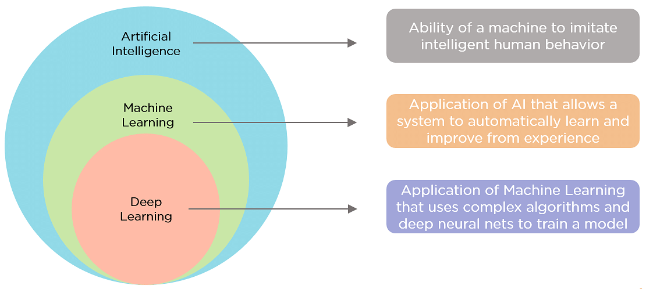

Artificial Intelligence is the concept of creating smart intelligent machines.

* Reactive Machines - These are systems that only react. These systems don’t form memories, and they don’t use any past experiences for making new decisions.
* Limited Memory - These systems reference the past, and information is added over a period of time. The referenced information is short-lived.
* Theory of Mind - This covers systems that are able to understand human emotions and how they affect decision making. They are trained to adjust their behavior accordingly.
* Self-awareness - These systems are designed and created to be aware of themselves. They understand their own internal states, predict other people’s feelings, and act appropriately.

Machine Learning is a subset of artificial intelligence that helps you build AI-driven applications.

* Supervised Learning, the data is already labeled, which means you know the target variable.
* Unsupervised learning algorithms employ unlabeled data to discover patterns from the data on their own. The systems are able to identify hidden features from the input data provided. Once the data is more readable, the patterns and similarities become more evident.
* Reinforcement learning is to train an agent to complete a task within an uncertain environment. The agent receives observations and a reward from the environment and sends actions to the environment. The reward measures how successful action is with respect to completing the task goal.

Deep Learning is a subset of machine learning that uses vast volumes of data and complex algorithms to train a model.

* Convolutional Neural Network (CNN) - CNN is a class of deep neural networks most commonly used for image analysis.
* Recurrent Neural Network (RNN) - RNN uses sequential information to build a model. It often works better for models that have to memorize past data.
* Generative Adversarial Network (GAN) - GAN are algorithmic architectures that use two neural networks to create new, synthetic instances of data that pass for real data. A GAN trained on photographs can generate new photographs that look at least superficially authentic to human observers.
* Deep Belief Network (DBN) - DBN is a generative graphical model that is composed of multiple layers of latent variables called hidden units. Each layer is interconnected, but the units are not.

1. **After reading the AI application scenarios in this chapter, please describe in detail a field of AI application and it’s scenarios in real life based on your life experience.**

Google Search

Google Duplex and Hold For Me

Google Recorder, Live Captions, and Transcribe

Image Editing — Remove Background & Enhance Resolution

Fall Detection and Car Crash Detection

1. **Which chip is for deep neural networks and Ascend AI processor. Please brief these 4 major modules.**

Software Architecture of Ascend Chips

* Process orchestrator: implements the neural network on Ascend AI chips, coordinates the whole process of effecting the neural network, and controls the loading and execution of offline models.
* Digital vision pre-processing (DVPP) module: performs data processing and cleaning before input to meet format requirements for computing.
* Tensor boosting engine (TBE): functions as a neural network operator factory that provides powerful computing operators for neural network models.
* Framework manager: builds an original neural network model into a form supported by Ascend AI chips, and integrates the new model into Ascend AI chips to ensure efficient running of the neural network.

1. **Elaborate on the development trends of AI in the future in your view**

Rapid Growth of Reinforcement Learning

AI-Driven Business Decisions

RPA Penetration Increases

AI Will No Longer Be So Reliant on Big Data

Ethical AI and AI Trustworthiness